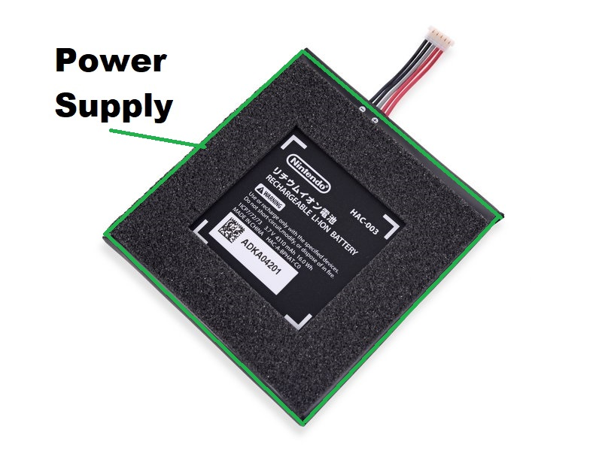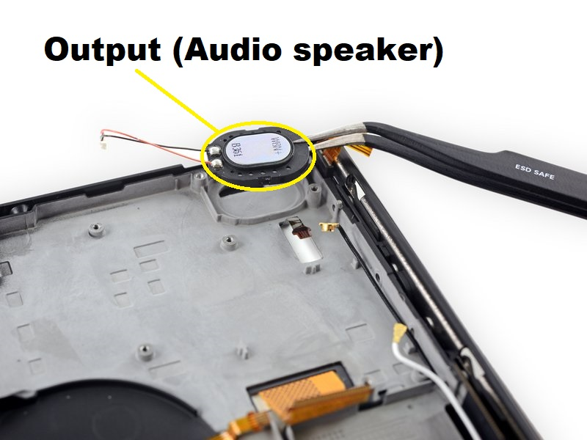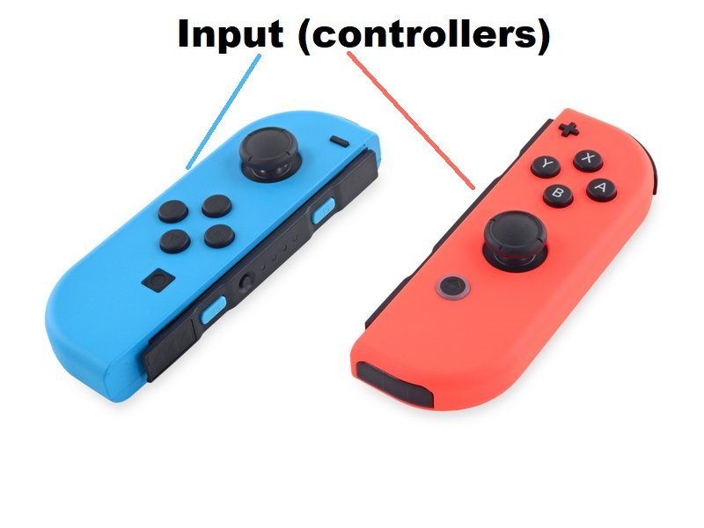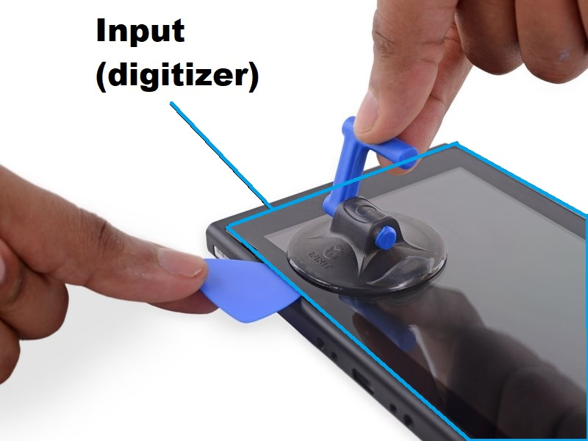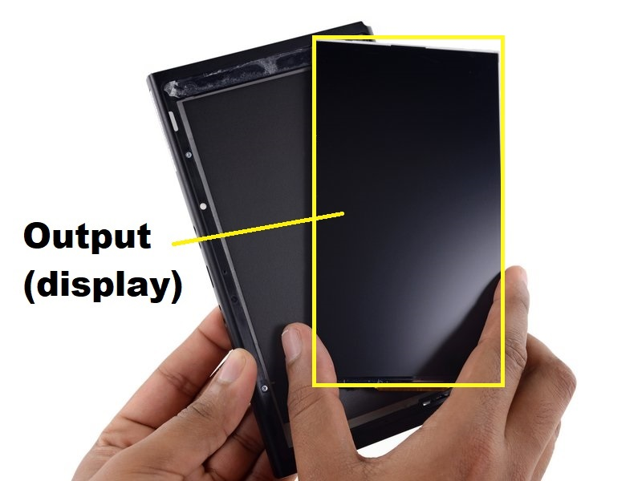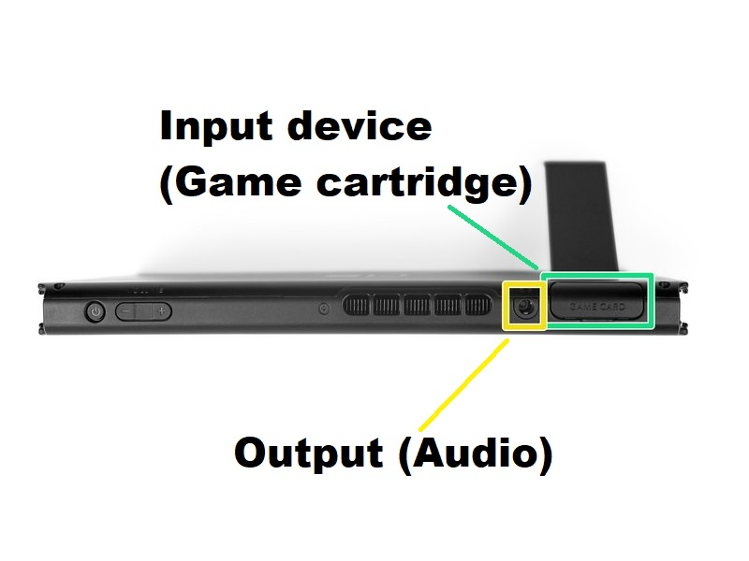**Nintendo Switch hardware teardown:**

**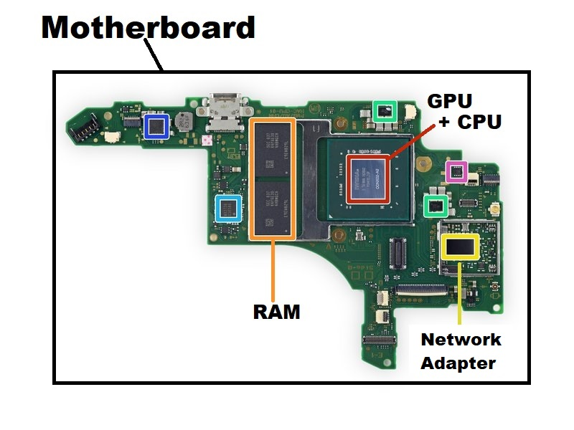  
Because of the peculiar hardware requirements of the switch, it’s primarily designed to be a mobile device with the ability to hook a display via a proxy device called “the dock”. It also has limited space to accommodate a sophisticated GPU like most other game consoles, and therefore has a two in one CPU+GPU; stronger than simple on-board graphics for laptops but less so than even a middle grade gaming PC.**

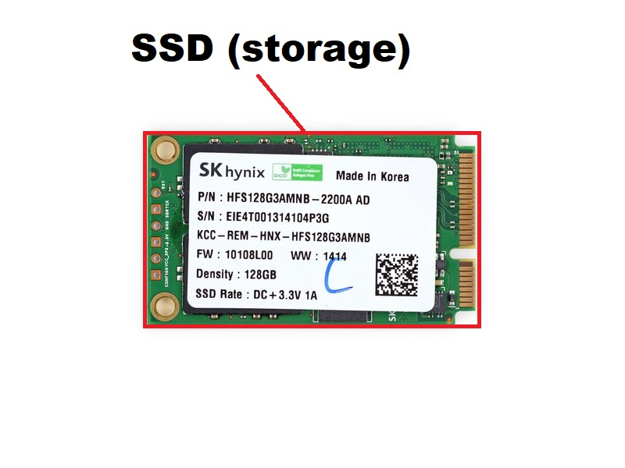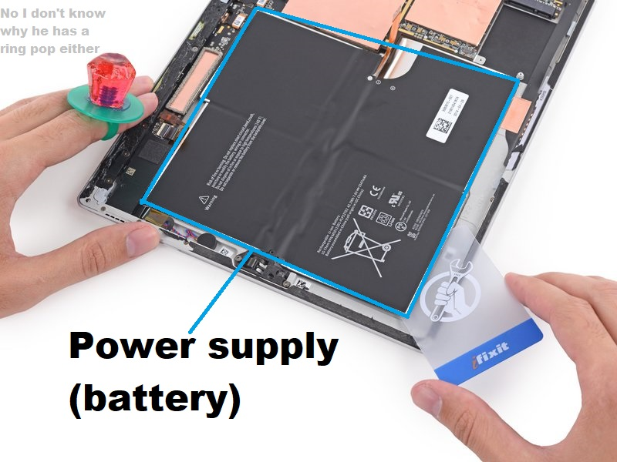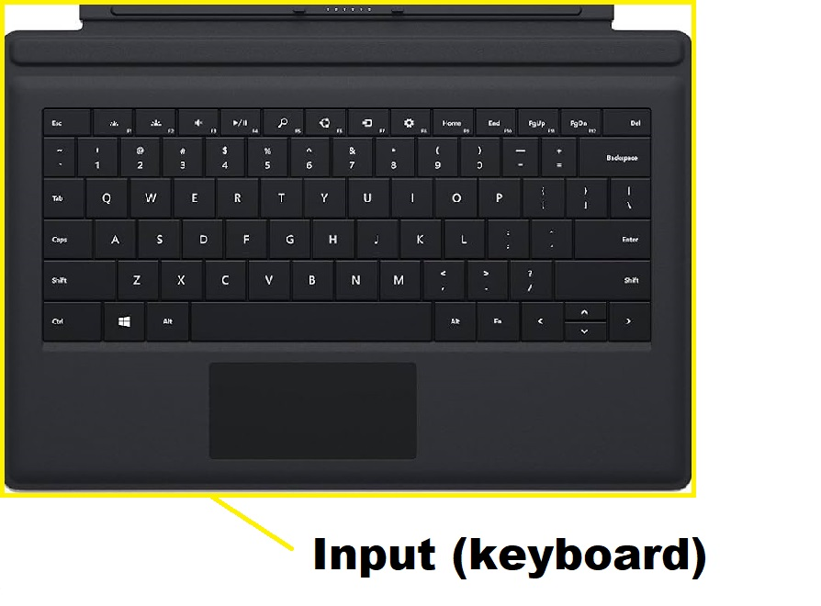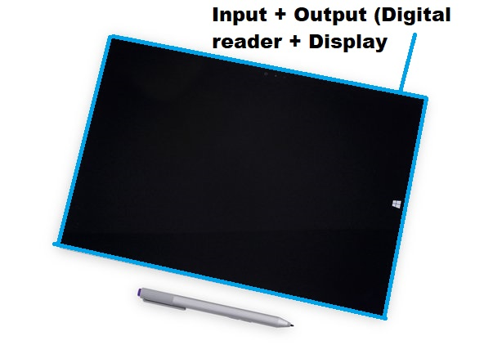**Microsoft Surface Pro 3 hardware teardown:**

**Closer to a laptop in terms of actual hardware specs, but with many tablet like traits. This is the laptop series I’ve used personally, and they’re quite convenient in the way you can swap to using the display input for hand written notes.**